Assignment 2 – Exploring the Data
- List the features and identify their types (nominal, numeric, etc.)
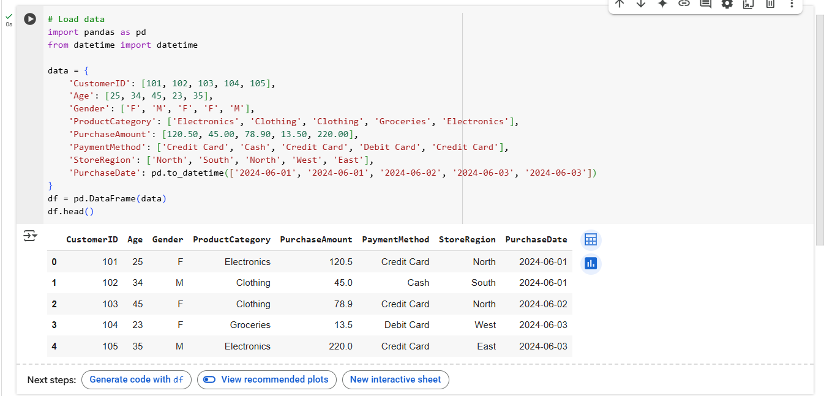
🔍 Describing the Dataset
Feature List and Data Types
Feature | Data Type | Description
Customer ID | Numeric (Int) | Unique ID for each customer
Age | Numeric (Int) | Customer’s age
Gender | Nominal (object) | Gender of the customer
ProductCategory | Nominal (object) | Product category purchased
PurchaseAmount | Numeric (float) | Total amount spent
PaymentMethod | Nominal (object) | Method used for payment
StoreRegion | Nominal (object) | Region where purchase was made
PurchaseDate | DateTime | Date of the purchase

- Summary Statistics (.describe() output)
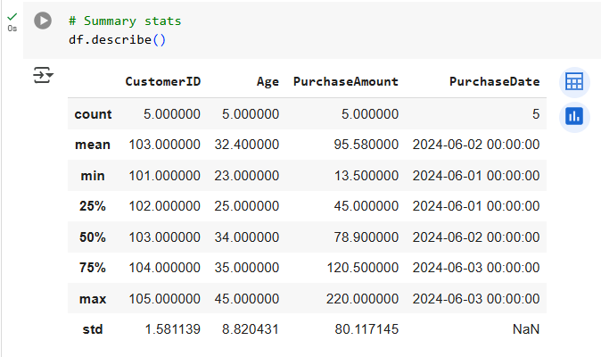
Count: 5 rows
Mean Purchase Amount: 95.58
Min Purchase Amount: 13.5
Max Purchase Amount: 220.0
Standard Deviation: 80.12
25% Quartile (Q1): 45.0
Median (Q2): 78.9
75% Quartile (Q3): 120.5
- Range, Mean and Standard deviation of PurchaseAmount
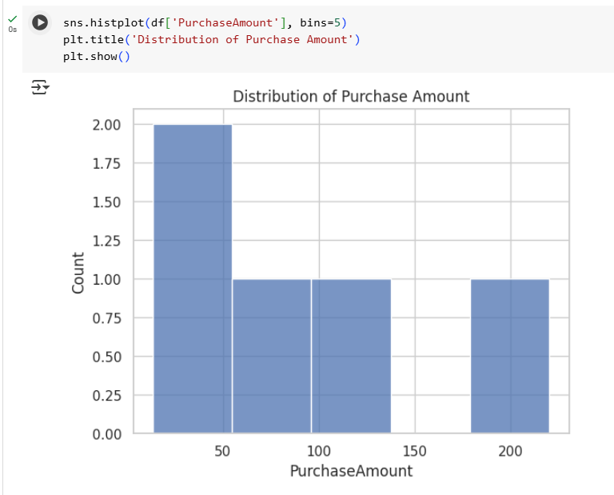
Range: 220.0 - 13.5 = 206.5
Mean: 95.58 (from .describe())
Standard Deviation: 80.12 (from .describe())
📊 Visualize the Data
- Include or describe two charts:
- Chart1: Histogram of PurchaseAmount
  - Why used: Shows the distribution of purchase values
  - Reveals: Most purchases are clustered in the lower range, with one high outlier
- Chart2: Bar Chart of PaymentMethod
  - 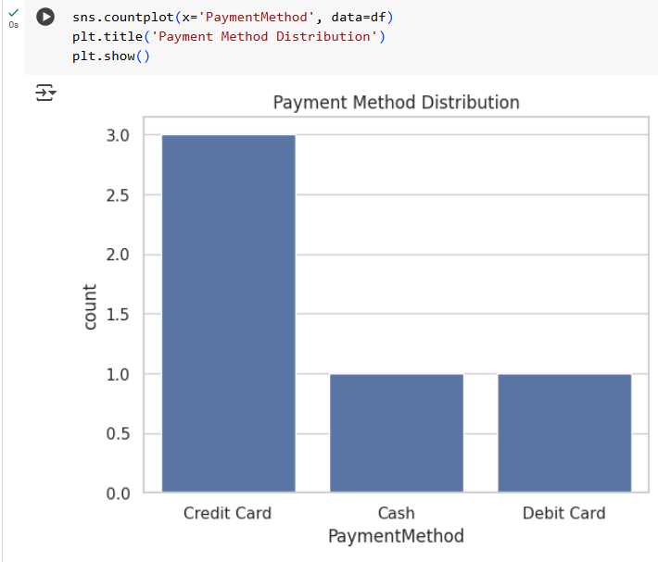
  - Why used: Categorical variable best visualized with bar chart.
  - Reveals: Majority of purchases are made with credit card.

🔗 Explore Relationships
- Correlation Heatmap
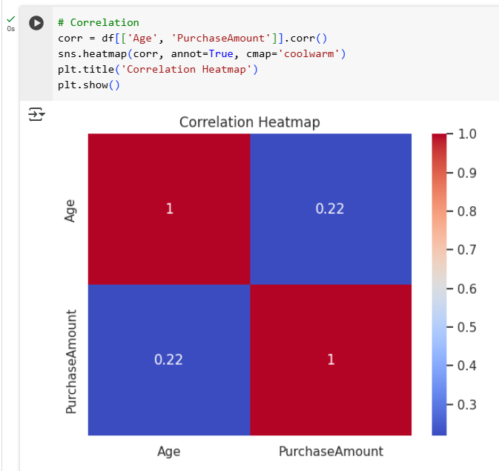
- Explored correlation between Age and Purchase Amount
- Correlation Coefficient: 0.22 (weak positive correlation)
- Interpretation
  - There is a slight positive relationship between age and spending. Older customers may tend to spend a bit more.
  - This weak correlation suggests age might be a minor factor in predicting purchase amount, but it shouldn’t be the only feature considered for modeling.

